Chapter 1 – Introduction
Nowadays FPGAs are big enough that you can implement many components on the FPGA; rather than having a dedicated DSP, processor and memory, you can implmenet all of this on a single FPGA.

Most FPGA vendors are fabless companies, meaning they just attempt to enhance the device architecture, software tools and IP cores. The manufacturing is all left to some other industry company.
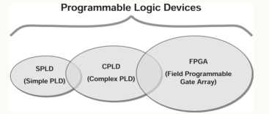

Chapter 2 – FPGA Fundamentals
There are Simple Programmable Logic Devices (SPLDs), Complex Programmable Logic Devices (CPLDs) and FPGAs. There is some overlap between the devies, but overall certain devices suit particular purposes more.

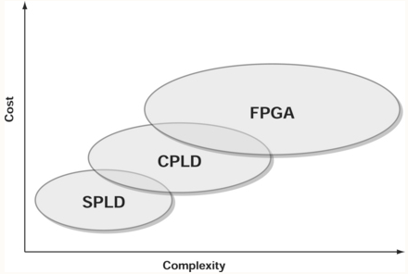
Overall, FPGAs are more complex, have a larger capacity and have more registers. You can generally implement a design in more complex logic devices, but not the other way around.

SPLD Device Overview
There is an array of Boolean ANDs and another array of Boolean Ors. There is only a little bit of routing available. The propagation delay is very low.

There are PALs and PLAs. PLAs allow for both AND and OR to be programmed, whereas the OR is fixed on PALs.

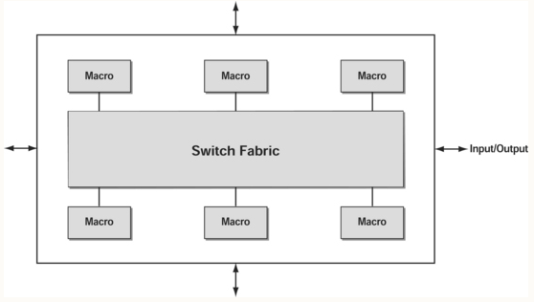
Both PAL and PLA have low pin count (16-24) and low number of logic cells (8-24). They use EPROM or EEPROM to store the configuration info.

CPLD
An extension of SPLDs. In its simplest incarnation, a CPLD is just a bunch of SPLDs combined together with a bunch of IO surrounding the perimeter.

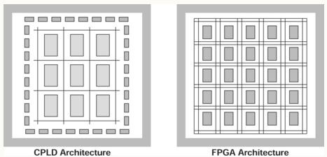
Larger CPLDs can implement functionality found in smaller FPGAs. If you plan on evolving your functionality over time, you might not want to use a CPLD. Though it might fit your design now, it is still lower in space than an FPGA.

The implmentation of logica and signal interconnectino is significantly different between CPLDs and FPGAs.

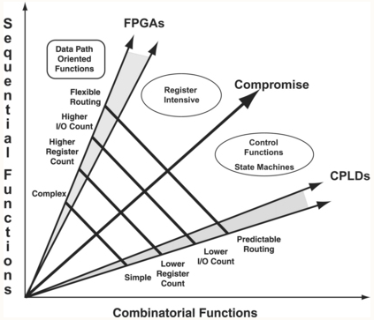
FPGAs tend to be more data-oriented at the cost of more complex architecture. CPLDs are well suited to combinatorial functions with limited register requirements, while FPGAs can implement larger, more register-intensive functionality.

FPGA Device Overview
Introduced in 1985 by Xilinx to address the gap between CPLDs and ASICs.

They have a large number of Logic Cells and a large number of Flip Flops.

There are kind of two dimensions you can play with: IO capability and Logic density. Some families and devices will have a higher ratio of logic-to-I/O and are referred to as logic-centric. Other devices will have relatively more I/O than logic and are referred to as I/O-centric.

FPGA Types
There are two main kinds of FPGAs: reprogrammable and one time programmable. There are four main methods for configuring FPGAs
- SRAM Based:
  - An external device programs the device on power up. Configuration is volatile and can be reconfigured in circuit.
- Anti-Fuse based:
  - Burning internal fuses. One time programmable
- EPROM Based:
  - Configuration in non-volatile, but must be programmed off board.
- EEPROM Based:
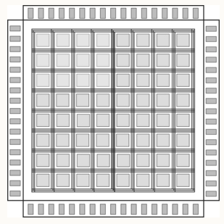
  - Configuratino is non-volatile. Must be programmed off board

SRAM Based FPGA Architecture
An FPGA is an IC with a centeral array of logic blocks that can be connected together through a configurable interconnect routing matrix. Around the logic blocks is a ring of IO.

Logic block structure
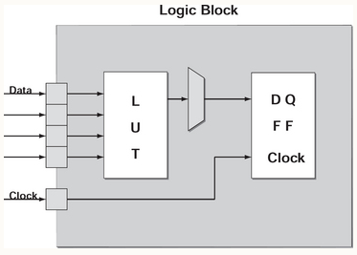
Different families have different logic block architecture. Each manufacturer has their own name for the lowest-level FPGA logic block (logic cell, slice, macrocell, logic element). This book will use the term slice. Generally each slice has one or more LUTs along with one or more flip-flops, signal routing logic, control signals and carry logic. For advanced FPGA families, the layout of a slice is generally quite complicated, the picture is a very simplified architecture.

The most common LUTs have 4 inputs, but you should be familiar with your particular device to make the most successful implementation.

Slices can be combined together to form a larger structure. These are called tiles, configurable logic blocks (CLBs), logic array blocks (LAB) or MegaLAB, depending on the manufacturer. The picture to the right details a Xilinx CLB. This text will refer to them as CLBs
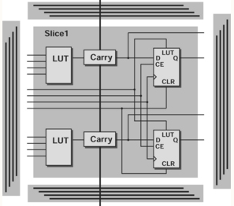Figure 1: CLB Layout

Different manufacturers, and even different FPGA families from the same manufacturers, have different CLB architectures.

Routing Matrix and Global Structures
Slices are arranged in a grid; the channels are vertical+horizontal, and there are programmable routing switches throughout the channels. The switches can provide “either a 180 or 90 degree routing path.”

constraints have a significant impact on routing path implementation, which affects logic timing. This will be given its own chapter.
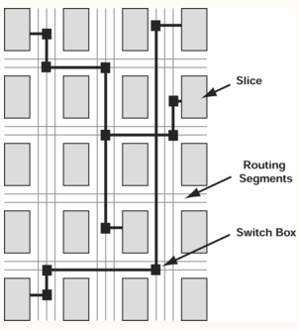Figure 2: CLB Routing

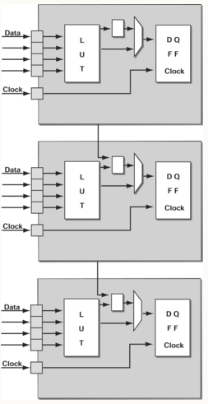Figure 3: Carry Chain Logic
Carry chain logic is another important routing mechanism, it can be used to construct large arithmetic functions. These can either be horizontal or vertical, depending on the implementation of the FPGA.

FPGA IO Blocks
The ring of IO banks around the CLB array is used to interface with external components.

An IO Block (IOB) includes input and output registers, control signals, muxes and clock signals.
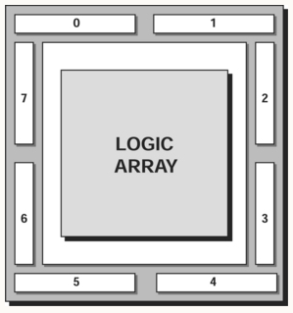Figure 4: IO Block

CMOS circuits user power in the indeterminate state, inputs left floating use extra power. Unused FPGA inputs should be tied to a value.

IOBs support many different types of IO interface standards in otder to interface with different types of logic. Both “single-ended” (PCI, LVTTL) and “differential operational modes” (LVDS, LVPECL) are typically supported.
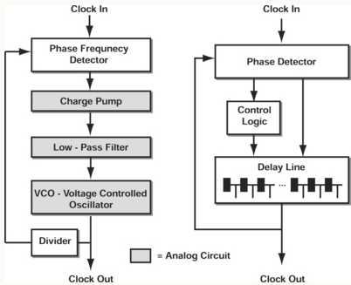Figure 5: PLL And DLL

FPGA Clock Resources
There is a CLOCK block, which is the primary element for handling, managing and adjusting FPGA local and system clocks. There are two different clock manipulation technologies: Phased Locked Loop (PLL) and Delay Lock Loop (DLL).

PLLs generate a desired clock phase or frequency my making adjustments in a voltage controlled oscillator. PLLs are analog circuits, and thus do bettern when supplied with “clean” power and ground. He says that it might be wise to supply split planes to provide isolated power and grounds, complicating board layout.

DLLs product the desired clock fphase and frequencyt by accessing signals from a “calibrated tapped dlay line circuit” inside the FPGA. DLLs are digital cirtuits.

There are both global and regional clocking techniques. Global clocking typically starts in the middle of the device and branches into smaller regions. FPGA devices are generally divided into four or more clocking regions. Differential clocking is often implemented for the global clock, allowing for things like DDR.

Memory
There are two primary types of memory: distributed memory and block memory. Distributed Memory takes advantage of LUTs being SRAM memory blocks. Block Memory is a dedicated implementation of SRAM in the FPGA.
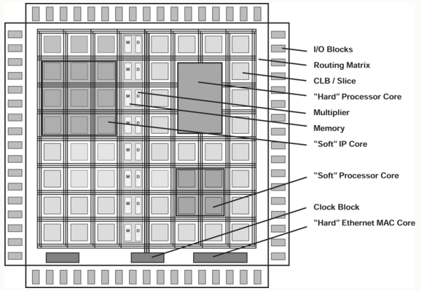Figure 6: FPGA Overview

Chapter 3 – Optimizing the Development Cycle
If the PCB and FPGA are coupled together properly during the initial design phase, limitations in the physical board layout can be resolved in logic by the FPGA. For example, if the correct signals are already tied to FPGA pins (even if there is no plan to use those in the original design) the FPGA can at some point later be implemented to use those signals.

He says that synchronous design is something that helps with design implementation, apparently there is an entire chapter devoted to that topic. It seems that it has to do with clocks: avoid gating clocks, avoid async inputs

When you design the board, its good to have validation in mind. Put LEDs, switches, power quality, headers, pads, etc in places where it is easiest to verify at each phase of the design cycle.
If possible, add in BIST (Built in Self Test) functionality into the design.

Chapter 4 – System Engineering

Chapter 5: FPGA Device-Level Design Decisions

5.3 Design Decisions
Different FPGA architectures have different data flow orientations – efficient FPGA dezigns are implemented in a way which takes advantage of the “architectural biases” of the FPGA architecture.
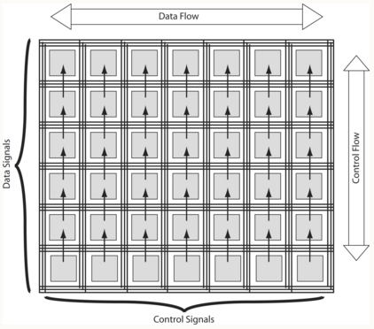
For example, the Xilinx Virtex family is designed for control to flow along Columns, and Data to flow along Rows. This sort of information can be very hard to track down.

Design constraints can be used by a developer to influence the implementation of the design.

The designer should avoid assigning critical signals to I/O pins that are close to die corners, since corners can impose routing limitations.

Interfacing the FPGA to external components involves an understanding of the voltage logic levels, slew rate, impedance and other factors typically defined within an I/O standard such as LVCMOS.

You have to really think about IO. There are different IO standards (pull up, pull down, differential, keeper, etc) and typically one IO bank can only have a single standard, so you have to think about your PCB layout in that regard. On a given IO bank, the number of IOs that can change at the same time is limited ; this is a device parameter known as Simultaneously Switching Outputs (SSO).

Clocking Signals
This is one of the most important things you need to pay attention to. Another common mistake involves not understanding the ranges, limitations, and exceptions for generating (multiplying and dividing) clocks within the internal FPGA clock management blocks. There are often limitations on the clock frequencies that can be generated and this will affect the clocks provided to the FPGA at the board level.

Configuration
There is an entire chapter dedicated to this topic. Certain pins are used for certain configuration methods, and you must be sure to meet requirements specified in the datasheet about these pins.

Internal Signal Termination
Poorly controlled signal impedances or unterminated controlled impedance signals will cause signal reflections, which will degrade signal and data quality and reduce the maximum possible system performance. Generally for proper signal termination you need devices outside of the FPGA, but some FPGA devices support termination internal to the package – note that this will increase the power dissipation though.

Unused IO
Another important use for unused pins is for support of access to nodes internal to the FPGA for testing and debug. ins should incorporate an in-series zero-ohm jumper close to the FPGA to maximize design flexibility. This can allow these pins to double as I/O for white wires if unforeseen signals must be accessed.
Chapter 7 – Design Implementation
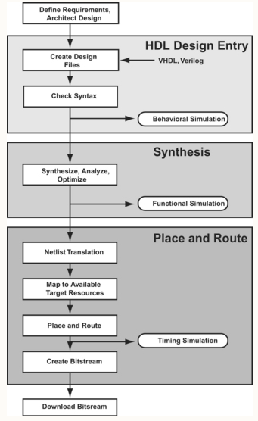
Logic Synthesis is when a tool converts HDL into a “gate level netlist specific to a target device.”

Place and route will determine where registers and gates should be placed within the FPGA fabric. This determines the paths between modules

7.2 Design Architecture
Synchronous design is the most preferred method of FPGA development, it leads to simplification of timing simulation, increased isolation of FPGA functionality from baord level timing issues and reduced impact on the design if the underlying FPGA component changes.

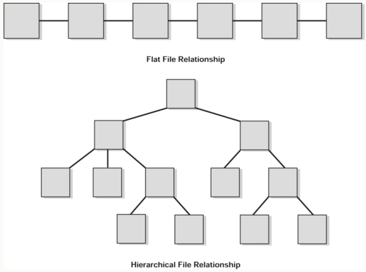
The two most popular design architectures are Flat and Hierarchical Relationships.

